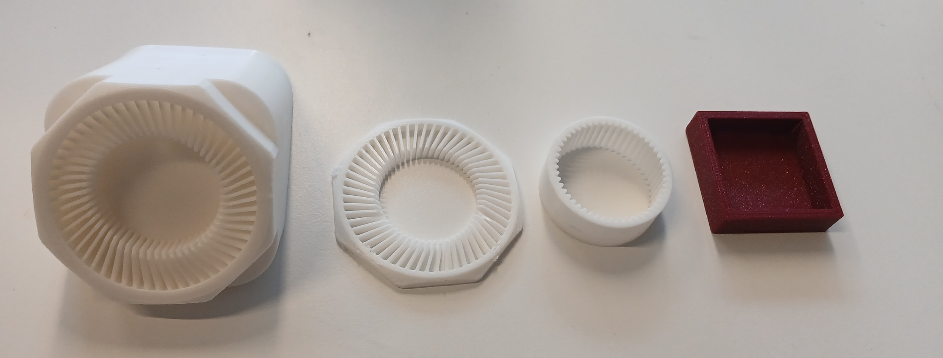The first prototype was made to be attached on a hand with an elastic. The second prototype was made to test/ try if the teeth will hang on the bottle cap but still not working. The third one we have changed the type of teeth and this one works because it hangs on the bottle cap. The last prototype is just the superior version of the third one, using the same teeth but just with a support that’ll allow the user to stick it on a wall, inspired by the beer bottle-opener.

However, we can still improve our project. We need to make it adaptable to different sizes of bottle caps, and different types of caps. We also need to make sure it works for the new caps, following the European law.

